**Week 7 Rome’s Expansion**

**Outline**

1. Bird’s-eye view of Roman expansion up to the year 129 BC.
2. First Punic War (264-241).
3. Inscription commemorating C. Duilius’ (cos. 260) naval victory at Mylae in 260 BC (earning him a triumph), his success in relieving Segesta—a town on Sicily—and in capturing Macela, another city.
4. *Deditio in fidem* (surrender into the faith of Rome).
5. Warships: trireme.

**Middle Roman Republic: Expansion**

1. Foreign Affairs Chronology 270-129 BC

|  |  |
| --- | --- |
| **Year** | **Event** |
| **280-275 BC** | Pyrrhic War |
| **c. 270 BC** | Rome had become the leading power in Italy |
| **264-241 BC** | First Punic War between Rome and Carthage |
| **241 BC** | Sicily becomes Roman province[1] |
| **238 BC** | Corsica and Sardinia become a Roman province |
| **218-201 BC** | Second Punic War[2]; victory for Rome |
| **200-197 BC** | Second Macedonian War; victory over Philip V of Macedon[3] |
| **197 BC** | Hispania Citerior and Hispania Ulterior become Roman provinces |
| **171-168 BC** | Third Macedonian War; Perseus defeated at Pydna; Macedonian Kingdom dissolved |
| **167 BC** | Roman province is established on the Illyrian coast |
| **150-148 BC** | Fourth Macedonian War; Roman victory over pretender Andriscus |
| **146 BC** | Macedonia becomes Roman province |
| **149-146 BC** | Third Punic War; Roman victory and destruction of Carthage |
| **146 BC** | Province of Africa formed |
| **129 BC** | Province of Asia formed[4] |

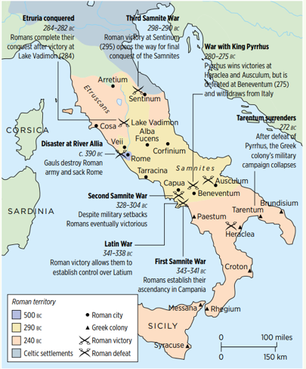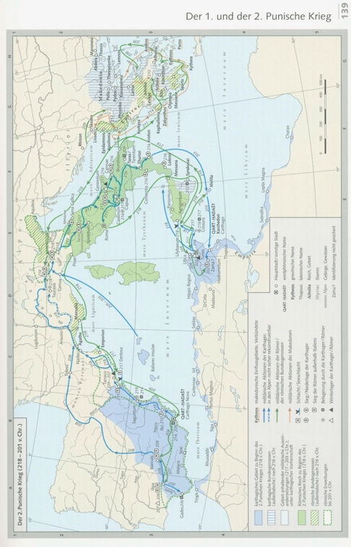

1. The First Punic War
2. 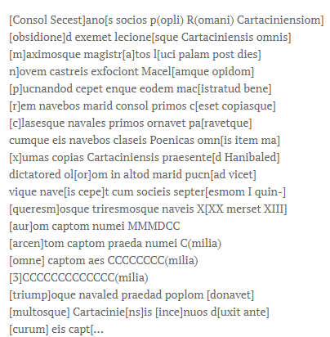Source

“The consul[5] delivered the Segestans, allies of the republic, from a Carthaginian blockade, and all the Carthaginian units, including their supreme commander, after nine days fled in broad daylight from their camp. He also captured the city of Macela by storm. And in the same command he as consul performed an exploit in his ships at sea, **the first Roman to do so**: the first he was to equip and train crews and fleets of fighting ships; and with these ships he defeated in battle on the high seas the Carthaginian fleets and likewise all the mightiest troops of the Carthaginians in the presence of Hannibal, their **admiral (dictator[6])**. And by force, he captured ships with their crews: 1 septireme, 30 quinqueremes and triremes[7]; 13 he sank.

Gold taken: 3,600 [and more] pieces.

Silver taken, together with booty: 100,000 [and more].

Total sum: 3,200,000 asses.”

He celebrated a naval triumph, bestowed a gift of money on the people, and led many Carthaginian captives in front of his chariot.”

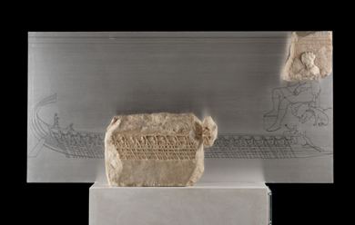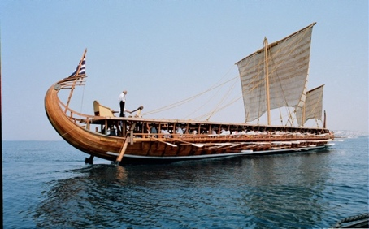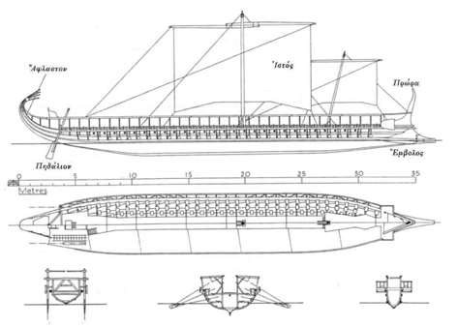

1. Concept: *deditio*

1. At the beginning, it was ruled by a praetor.
2. Carthage expanded to Spain and caused a conflict. Hannibal was defeated because of Rome’s delaying tactic, relying on buildings, and manpower.
3. He allied with Hannibal. After this war, Philip V was pushed out of Greece, and the Romans claimed that they gave back freedom to the Greeks by keeping Greece independent.
4. Attalus III, king of Pergamon, left his last will to give his kingdom to Rome.
5. C. Duilius.
6. Roman concept applied to understand other countries.
7. τριήρης, (*trieres*): ‘trireme’ (LSJ). *Trieris*: ‘having oars or rowers arranged in threes’ (adj.); ‘trireme’ (*OLD*).